John Michael Go
Career Entry Level Java Programming
Date: Jan. 16, 2013

DAY 4

Program Name: CRelation

Objective: Program will display relational operations between 2 numbers.

Algorithm:

- Program displays relational operations between 2 numbers.

Flowchart:

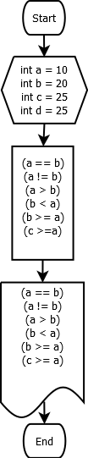

Pseudocode:

public class CRelation {

public static void main(String[] args) {
int a = 10;
int b = 20;
int c = 25;
int d = 25;

System.out.println("Relational Operators");
System.out.println("a = 10");
System.out.println("b = 20");
System.out.println("c = 25");
System.out.println("d = 25");
System.out.println();
System.out.println("1. a == b: " + (a == b));
System.out.println("2. a != b: " + (a != b));
System.out.println("3. a > b: " + (a > b));
System.out.println("4. b < a: " + (b < a));
System.out.println("5. b >= a: " + (b >= a));
System.out.println("6. c >= a: " + (c <= a));

}

}

Screenshot:

